**Plant Diversity Protocol for CPER-LTAR Observatories (EC Towers)**

**Monitoring Summary:** There are 3 LTAR Observatories or “EC Towers” at CPER they are located in Pastures NH, 15E, and 23E (see map below). At each observatory, there are three 20x20m plots within the fetch of the observatory’s monitoring equipment. Plant diversity will be monitored by measuring species composition and % cover of vegetation, abiotic features, and non-vascular species with in subplots of the 20x20m plots.

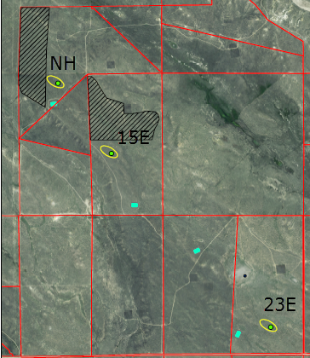

**LTAR Observatory locations (ovals with green dots). Note: There is no tower in the 23E location, so look for series of cages.**

**Equipment:**

-Clipboards -Data Sheets -Five 50m measuring tapes

-12 mega pixel camera w/extra batteries -Dry erase board w/markers -1x1m steel frames

-Surveyor Pins - Pin Flags (20) -Plastic Bags for unknown species -Flagging Tape

**Field Sampling**

**Step 1: Find and Mark Plots and Sub-Plots**

Each of the three 20x20m plots are marked with white plates at the corners and center (See Figure below). The plots are numbered from south to north, 1, 2, and 3. Use pin flags to temporarily mark the corners and centers of each 20x20m plot. Then use the pin flags to mark the corners of 100m2 subplots by measuring 10m from the nearest corner flag. Next, mark the corners of the 10m2 subplots by measuring 3.16m from the nearest corner as shown below. Flagging tape can be used to delineate the borders of the 10m2 subplot, if necessary. The 1x1m steel frames can be placed in the corners of each plot as shown below. Be sure not overlap the steel frame with the white marking plate.

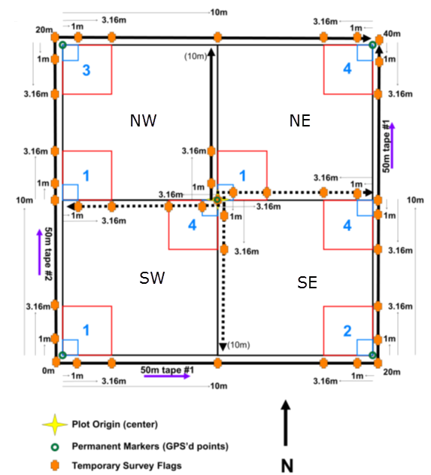

**Step 2: Take photos of 1x1m subplots**

On the dry erase board, write the pasture, plot, subplot, and date information. Example: 15E, plot 1, subplot NW, 6-30-16. Place the white board facing the sky on the southern end of the 1x1m frame. Snap the photo from the middle-southern side of the frame with the entire 1x1 frame in the camera frame, including the white board. Note: Be cautious of your shadow.

**Step: 3: Identify and record cover and height of vascular plant species in the 1x1m subplot.**

Fill out the appropriate metadata on the data sheet. Record all species present and include the percent foliar and basal cover of each to the nearest 1%. Enter 0.5% for estimates less than 1%. Use the calibration marks on the 1x1m frame to more accurately estimate cover (see below). It may help to keep card board cut-outs of 1%, 5%, and 10% to calibrate your eyes. Also record basal cover of abiotic features (bare ground, rocks, dung, etc), litter (non-rooted dead organic matter), non-vascular species (mushrooms, moss, lichen, etc). Total basal cover should not exceed 100%. Foliar cover may exceed 100% due to overlap.

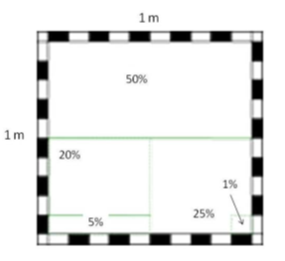

**1x1m steel frame with 10cm painted increments.**

**Step 4: Identify all species in the 10m2 subplot.**

Record the identity of all species with stems in each 10m2 nested subplot as described for the 1m2 nested subplot. It is not necessary to record species already documented in those 1m2 nested subplots in each respective 10m2 nested subplot. However, it is acceptable to list species that were observed in the smaller, 1m2 nested subplot (it may be difficult to remember, especially given the repetitive nature of the plot) as these records can be cleaned when processed.

There is no specific time that should be spent looking for plant species during search efforts. The search is best thought of in terms of a species-accumulation curve. Initial searching is likely to result in more species. A general guideline: if new species are being found, keep searching. If after five to ten minutes of gently moving dominant species to look for small and locally rare individuals – even crawling if necessary – no new species are found, then spend another five minutes and move on.

**Step 5: Identify all species in the 100m2 subplot.**

Record the identity of all plant species with stems in each 100m2 subplot as described for the 1m2 nested subplot. It is not necessary to record species already documented in nested subplots in each respective 100m2 subplot. However, it is acceptable to list species that were observed in the smaller, 1m2 and 10m2 nested subplots (it may be difficult to remember, especially given the repetitive nature of the plot)as these records can be cleaned when processed.

As with searching the 10m2 nested subplot, there is no specific time that should be spent looking for plant species during search efforts. The search is best thought of in terms of a species-accumulation curve. Initial searching is likely to result in more species. A general guideline: if new species are being found, keep searching. If after ten minutes of gently moving dominant species to look for small and locally rare individuals – even crawling if necessary – while searching the entire subplot and no new species are found, then spend another ten to fifteen minutes and move on.

**Step 6: Clean-up and QAQC**

After all plots are completed for a given pasture, collect all the temporary pin flags and flagging tape. Then, have one person collect all datasheet to check for subplot completion. Be sure to discuss any unknown species with experience staff and other crew members. Lastly, send all 1x1m frame photos to the crew leader or other designated person.